|  |
| --- |
| ***Social Distance Detection*** |
| ***Wireframe Documentation*** |

**INPUT**

1. **Video Frame (.mp4)**

$ python social_distance_detection.py --input TestVideo.mp4

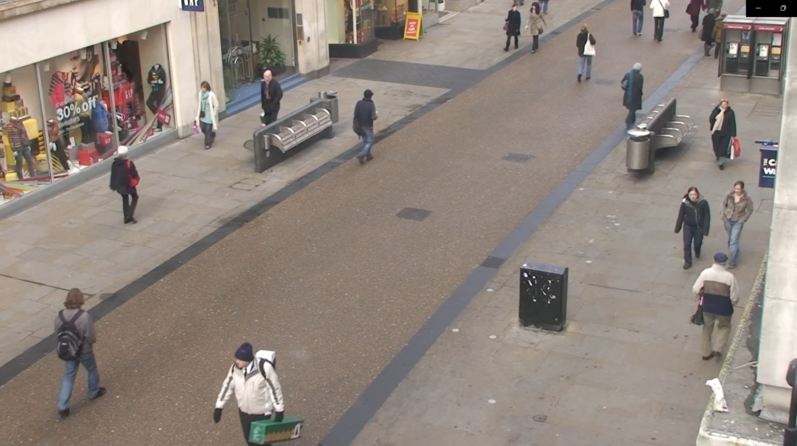

1. **Web Cam video Frame (live)**

**OUTPUT**

